June 5, 2020
Dear Families,

Fourth grade has come to an end, and it has been a great year with my wonderful class, both in the classroom and during the school shut down. This certainly was not something any one of us expected. I am so incredibly proud of how well all my students faced these challenges. We still smiled, laughed, shared, and learned during our weekly Zoom meetings and individual video calls on Teams.
I’d like to take this opportunity to thank you for allowing me to influence your child’s life this school year. It has been a pleasure getting to know your child and being a part of their lives. We have spent the year working towards independence, responsibility, and organization. We have learned about physical science, economics, government, math concepts/facts, reading strategies, and writing for different purposes. We have created biography book reports, opinion essays, and a lighthouse essay with each child’s own visual representation. Yet, throughout all of this, I hope your child has developed a love of learning that will motivate them to continue growing into a successful individual that they have become.

Fifth grade will be an exciting year! The fifth grade teachers are an exceptional team who will challenge and motivate your child. Daily reading, I believe, is one way to keep your child’s skills sharp! Also, continue practicing math facts!

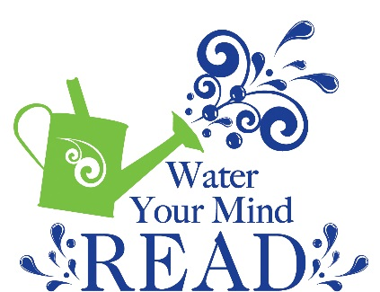
I wish you a restful, peaceful, and enjoyable summer, and once again, THANK YOU for sharing your wonderful child with me this year.

Sincerely,
Mrs. Munro

